

**Walchand College Of Engineering, Sangli.**

**(An Autonomous Institute)**

**Department of**

**Computer Science and Engineering**

**Mini-Project Synopsis**

on

**Detection Number Plate of moving vehicle**

### by

Sanket Jadhav (2020BTECS00005)

Somesh Sharma (2020BTECS00008)

Rushikesh Ware (2020BTECS00012)

### Under the Guidance of

### **Dr. B. F. Momin**

|  |
| --- |
| **Dr. M. A. Shah** |
| HOD |
| Computer Sci. & Engg. Dept, |
| WCE, Sangli |

### 2022-23

1. **Problem statement:**

Detecting Number Plate of Moving Vehicle.

1. **Abstract**

Number plate recognition is an image processing technology which uses registration number from number plate to identify the vehicle. The objective is to design an efficient automatic authorized vehicle identification system by using the vehicle number plate. The system can be implemented on the entrance of any premises for security control. It first captures the picture of moving vehicle and then extracts the number from its registration plate. The extracted number is checked for its occurrence in local database and accordingly action can be performed.

1. **Problem Domain**

Security in Transportation.

1. **Objectives**
2. Study of Easyocr, Yolo for image processing.
3. Design an algorithm which can extract a registration number from image of a vehicle having number plate.
4. Dashboard for vehicle entry and exist.
5. Analysis about Accuracy of different algorithms for detecting number plate of vehicle.
6. **Outcomes/ Deliverables**

System implemented on CCTV to detect number plate of moving vehicle and verify it.

1. **Project Potentials**
2. Use to detect any suspicious vehicle in a premises.
3. As there are number of vehicles engaged in mining activity it is important to detect a suspicious truck that enters in mining area.
4. Parking Management.
5. The system can be used for detection of stolen vehicles. The detected plates are compared to those of reported vehicles.
6. **Project plan**

LA-1:

Study of Easyocr.

Implementing Prototype.

LA-2:

Implement an algorithm which can detect a number from image of vehicle. Integrate with CCTV.

1. **Methodology**

A vehicle when being captured on surveillance camera undergoes planar motion. Hence a blurred image is obtained. Therefore, Weiner Filter is used for image deblurring. Most of the license plate have different background and foreground color. Need to train the model with YOLO custom weights to successfully complete the localization of the license plate. [2]

The YOLOv3 algorithm is employed, which is the most recent version of the YOLO (You Only Learn Once) algorithm, with numerous design improvements. YOLO algorithm used for the object detection and it is one of the fastest object detection algorithms and it is good choice for real time object detection. This algorithm detects the predict class labels and also detect the location of the object too and also detect the multiple objects in an image.

Bounding box is given scores based on the class that might be associated. Here there is only one class called Number plates. Yolo methodology of matrix-based approach of dividing the image into regions and finding Region of Interest (ROI). Different possibilities of ROI are marked by Yolo without any filters.

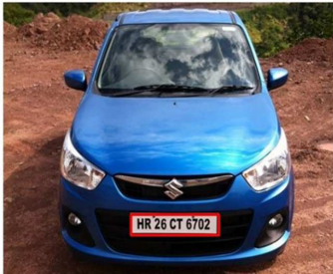

Number plate detection using YOLO

Once the image is successfully cropped for the required part, it needs to be enhanced with image processing techniques and then this will be fed into a CNN(Convolutional Neural Network) model which is developed to obtain the prediction of character. The input format used is 28 * 28 pixel-based image of each character. CNNs will compare input images pixel by pixel or group of boxes. The regions that appearances for are called landscapes. By definition rough feature contests in roughly the similar places in two images. To determine the match of a feature to a spot of the image, simply multiply every pixel in the feature by the rate of the matching pixel in the image.

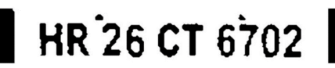

Image enhancement of the ROI image

The detected number plate is then partition to extract the separate characters. Contour sorting mechanism are deployed to detect all possible contours based upon the size height width and various other parameters such that only the valid contours are kept. For the optical character recognition part, segmented the data set from the available Indian license plates one by one and then segregated, cleaned and organized the data into 36 classes each from 0 to 9 and A to Z and finally trained the model with CNN multi layered model.

At the end, save theses details to database. Process the data & view it on website.

1. **UML diagrams**

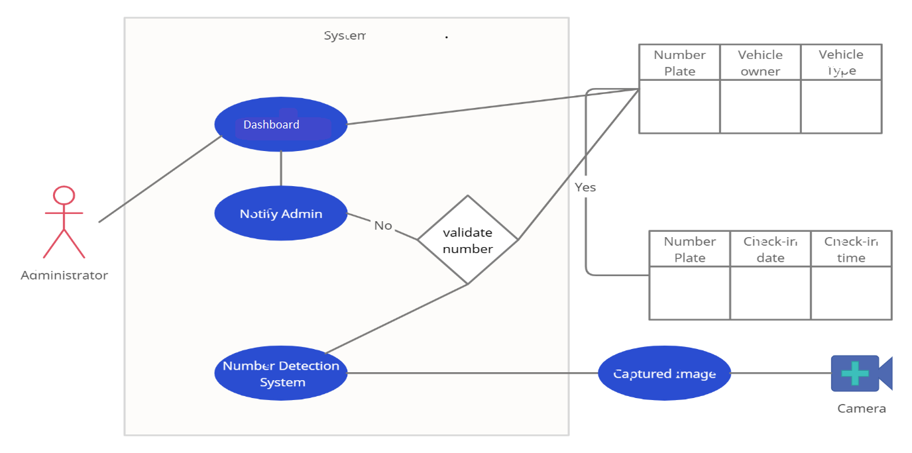

1. **References**
2. Prasad Molawade, Shruti Shanbhag et. al., “Number Plate Recognition using Machine Learning”, Volume 1 Issue 1.
3. Tella Pavani, DVR Mohan, “Number Plate Recognition by using open CV- Python”, International Research Journal of Engineering and Technology (IRJET) e-ISSN: 2395-0056 Volume: 06 Issue: 03.
4. Shashidhar R, Roopa M et. al., “Vehicle Number Plate Detection and Recognition using YOLO-V3 and OCR”, 2021.
5. G. Hsu, A. Ambikapathi, S. Chung and C. Su, "Robust license plate Car License Plates Recognition Using Neural Network detection in the wild," 2017 14th IEEE International Conference on Technologies," 2019 International Conference "Quality Advanced Video and Signal Based Surveillance (AVSS), 2017, pp. Management, Transport and Information Security, Information.
6. L. Xie, T. Ahmad, L. Jin, Y. Liu and S. Zhang, "A New CNN-Based and Shashidhar R “Detection of Non-Helmet Riders and Extraction

Method for Multi-Directional Car License Plate Detection," in IEEE of License Plate Number using Yolo v2 and OCR Method” Transactions on Intelligent Transportation Systems, vol. 19, no. 2, International journal of Innovative Technology and Exploring.